Syntax of Java Program
package packagename;
import packagename;
class classname
{
variables;
methods/constructors;
main method()
{
// executing code .
}
}

Example:
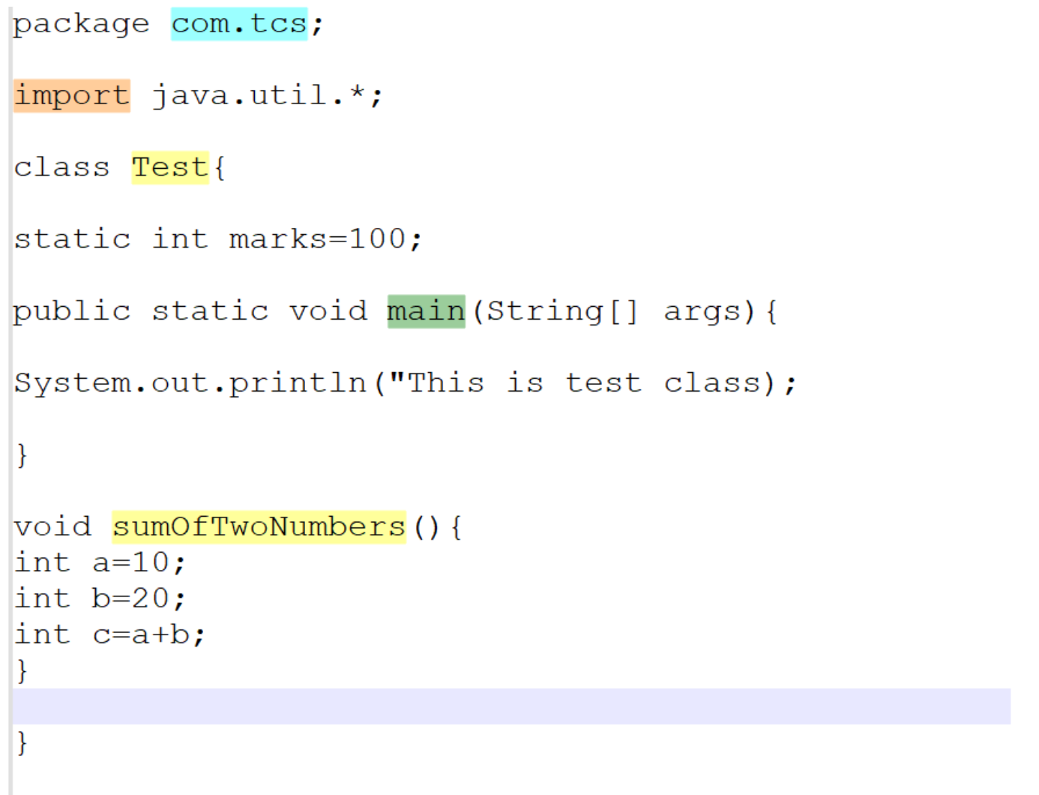

Rules for writing java program
Package Statement:
- Packages are used for better code segregation.
- Packages is mainly used in real time projects.
- Package consists set of java programs.
- Package provides access control.
- Will discuss in future about Package in detail.
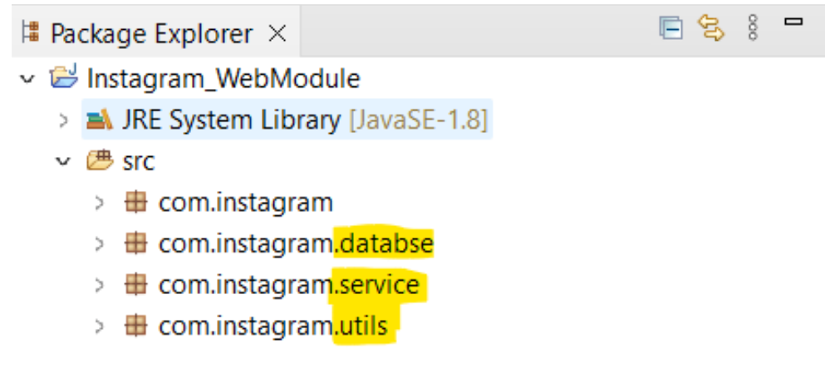
Import Statement
- Import statement is used to import packages or certain classes from packages.
- It is written after package statement and before the class definition.
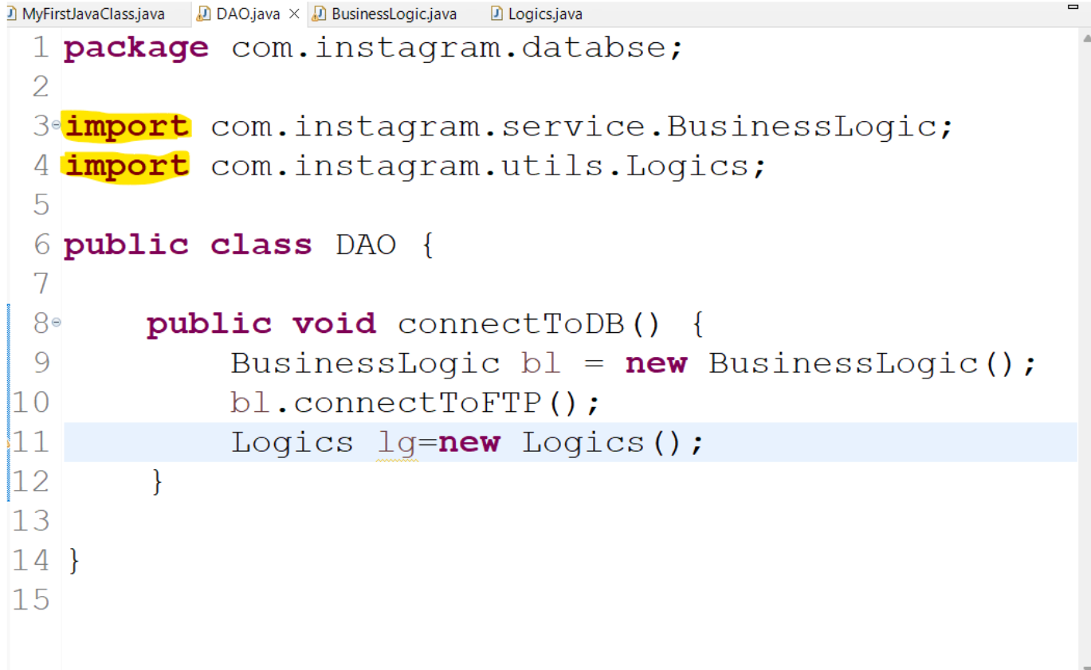
Class
- Class is the blueprint for creating classes.
- Class name can be given in CamelCase format ie, capital letter for every new word with no spaces between them.
- Java will never accept spaces in class name.
- Java class name shouldn’t start with numbers.
- Mostly prefer your class name to be user understandable not just like random names.
- Java class name should not start with special symbols like _ , $ etc.

Syntax:
Class Classname
Example
Class MyFirstClass
{
}

Main Method in Java Program
- The execution of a program starts from main method.
- Syntax of main method is as follows.
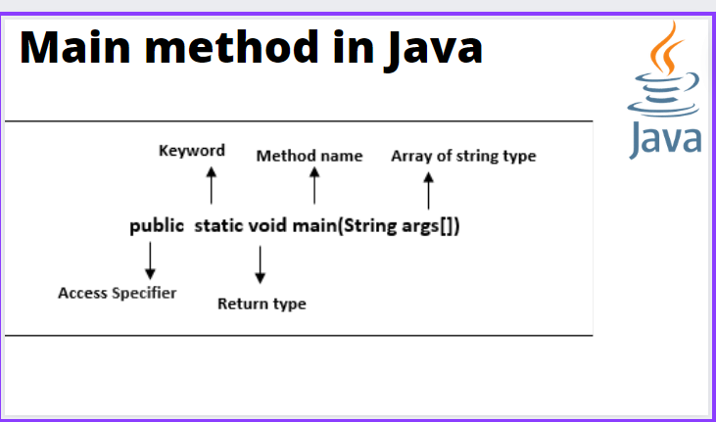

Variables
- A variable is a container which holds the value while program is being executed.
- We have to declare variables along with its datatypes.
Ex: int a;
- Here a is a variable and we are giving its datatype as int for the variable a.
Types of Variables:
- There are 3 types of variables
- Static Variables
- Instance variables (Non-static)
- Local Variables.
Static Variables:
- Variables which are declared outside the main method and inside the class by defining as static is known as Static Variables.
Instance Variables:
- Variables which are declared inside the class but outside of methods, constructors or blocks.
- It should not be declared as static.
Local Variables:
- Variables which are declared inside the method is known as local variables.
- Methods outside this method in the same class are not even aware of this variable existence.
Ex:
Class VariableDemo
{
Static int a = 100; // Static Variable
Void m1()
{
Int b = 10; // Instance Variable
}
Public static void main(String args[])
{
Int c = 5; // Local Variable
}
}
}

